ReactJS Week 7

# 9. cricketapp

React Code:

// cricketapp - ListofPlayers and IndianPlayers Components  
import React from 'react';  
  
const ListofPlayers = () => {  
 const players = [  
 { name: 'Virat', score: 90 },  
 { name: 'Rohit', score: 45 },  
 { name: 'Rahul', score: 75 },  
 { name: 'Jadeja', score: 60 },  
 { name: 'Pant', score: 55 },  
 { name: 'Ashwin', score: 80 },  
 { name: 'Bumrah', score: 40 },  
 { name: 'Shami', score: 35 },  
 { name: 'Gill', score: 95 },  
 { name: 'Surya', score: 100 },  
 { name: 'Iyer', score: 70 }  
 ];  
  
 const highScorers = players.filter(p => p.score >= 70);  
  
 return (  
 <div>  
 <h2>High Scoring Players</h2>  
 {highScorers.map(player => (  
 <p key={player.name}>{player.name} - {player.score}</p>  
 ))}  
 </div>  
 );  
};  
  
export default ListofPlayers;

Output Screenshot:

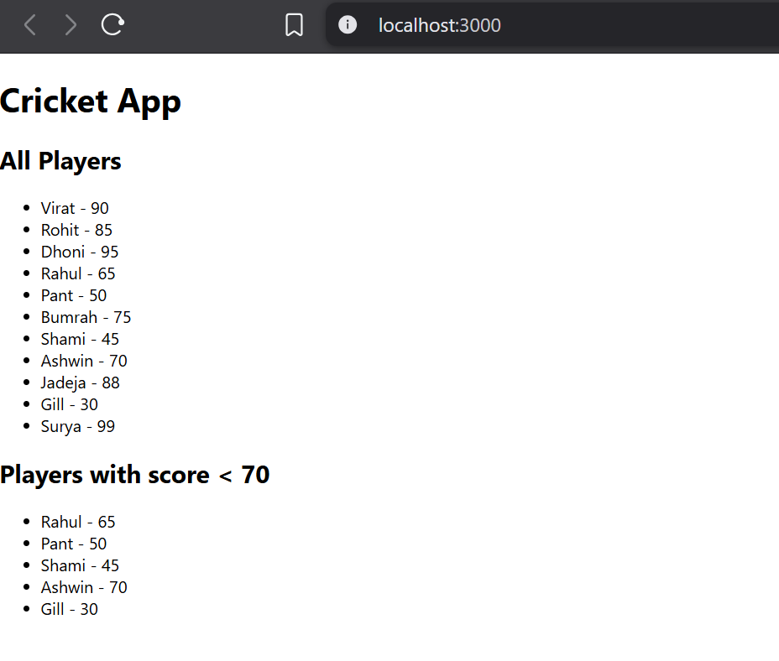

# 10. officespacerentalapp

React Code:

// officespacerentalapp - JSX Example  
import React from 'react';  
  
const OfficeApp = () => {  
 const officeSpaces = [  
 { name: 'Regus', rent: 45000, address: 'Banjara Hills' },  
 { name: 'WeWork', rent: 70000, address: 'HiTech City' }  
 ];  
  
 return (  
 <div>  
 <h1>Office Space Listings</h1>  
 {officeSpaces.map((office, index) => (  
 <div key={index} style={{ color: office.rent < 60000 ? 'red' : 'green' }}>  
 <h3>{office.name}</h3>  
 <p>Rent: ₹{office.rent}</p>  
 <p>Address: {office.address}</p>  
 </div>  
 ))}  
 </div>  
 );  
};  
  
export default OfficeApp;

Output Screenshot:

# 11. eventexamplesapp

React Code:

// eventexamplesapp - Event Handling  
import React, { useState } from 'react';  
  
const EventExamplesApp = () => {  
 const [count, setCount] = useState(0);  
  
 const increment = () => {  
 setCount(count + 1);  
 console.log("Hello! Count increased.");  
 };  
  
 const decrement = () => setCount(count - 1);  
  
 const sayWelcome = (msg) => alert(msg);  
  
 const handleClick = () => alert("I was clicked");  
  
 return (  
 <div>  
 <h2>Counter: {count}</h2>  
 <button onClick={increment}>Increment</button>  
 <button onClick={decrement}>Decrement</button>  
 <button onClick={() => sayWelcome("Welcome!")}>Say Welcome</button>  
 <button onClick={handleClick}>OnPress</button>  
 </div>  
 );  
};  
  
export default EventExamplesApp;

Output Screenshot:

# 12. ticketbookingapp

React Code:

// ticketbookingapp - Conditional Rendering  
import React, { useState } from 'react';  
  
const TicketBookingApp = () => {  
 const [isLoggedIn, setIsLoggedIn] = useState(false);  
  
 return (  
 <div>  
 <button onClick={() => setIsLoggedIn(!isLoggedIn)}>  
 {isLoggedIn ? 'Logout' : 'Login'}  
 </button>  
 {isLoggedIn ? <UserPage /> : <GuestPage />}  
 </div>  
 );  
};  
  
const UserPage = () => <h2>Welcome, Book your Ticket!</h2>;  
const GuestPage = () => <h2>Please login to book tickets.</h2>;  
  
export default TicketBookingApp;

Output Screenshot:

# 13. bloggerapp

React Code:

// bloggerapp - Conditional Rendering Multiple Components  
import React, { useState } from 'react';  
  
const BloggerApp = () => {  
 const [view, setView] = useState("books");  
  
 return (  
 <div>  
 <button onClick={() => setView("books")}>Book Details</button>  
 <button onClick={() => setView("blogs")}>Blog Details</button>  
 <button onClick={() => setView("courses")}>Course Details</button>  
  
 {view === "books" && <BookDetails />}  
 {view === "blogs" && <BlogDetails />}  
 {view === "courses" && <CourseDetails />}  
 </div>  
 );  
};  
  
const BookDetails = () => <div>React Book</div>;  
const BlogDetails = () => <div>Learning React Blog</div>;  
const CourseDetails = () => <div>Full Stack Course</div>;  
  
export default BloggerApp;

Output Screenshot:

